1.

Given probability density function of x,

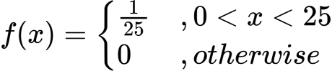

Expected value of x,

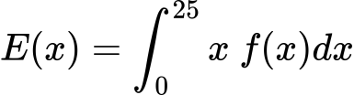

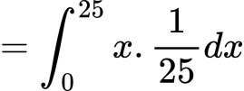

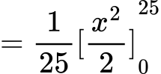

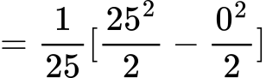

C:/Users/BAB AL SAFA/AppData/Local/Temp/wps.VMXVIqwps

Therefore, in long run the commuter is expected to wait, at the station for the train to arrive from the time he reached the station, for 12.5 minutes.

2.

Given random variable, x and it’s probability mass function P(x)=f(x),

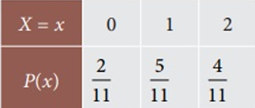

So, the expected value of x,

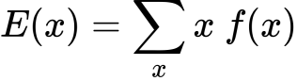

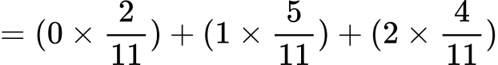



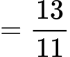

C:/Users/BAB AL SAFA/AppData/Local/Temp/wps.vaElfbwps

Therefore, the expected number of women in the interview pool is 1.182

3.

(3.1) Given table,



So, total number of people (in 1000’s)

= (5+10+25+50+100+120+140+5+10+50+100) = 615

|  |  |
| --- | --- |
| X | P(X) |
| 160  162  164  166  168  170  172  174  176  178  180 | 0.008  0.016  0.041  0.081  0.163  0.195  0.228  0.163  0.081  0.016  0.008 |
|  | ΣP(X) = 1 |

So, the mathematical expectation,

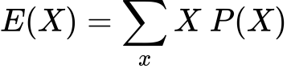

C:/Users/BAB AL SAFA/AppData/Local/Temp/wps.eVosynwps

wps

wps

.’. E(X) = 170.699

(3.2)

The most likely hight is the one with the highest propability. That is;

MAX(P(X)) = 0.228 with a hight of 172 cm.

So, the most likely height is 172 cm.

(3.3)

Total population = 5 + 10 + 25 + 50 + 100 + 120 + 140 + 100 + 50 + 10 + 5

= 615 Thousands

50% of the population = 615 * 50%

= 307.5 Thousands

P(X < h) > 0.5

We sum the probabilities starting from the smallest height until we reach a cumulative probability of at least 0.5

|  |  |  |
| --- | --- | --- |
| Height (h) | Frequency (f) | Cumulative frequency (FC) |
| 160  162  164  166  168  170  172  174  176  178  180 | 5  10  25  50  100  120  140  100  50  10  5 | 5  15  40  90  190  310  450  550  600  610  615 |

A rolling sum shows that the population of people with height less than or equal to 170 cm is 310 thousands which is nearly 50% of the population.

(3.4)

We got from (3.1),

E(X) = μ(X) = 170.699

Variance,

σ2  = E(X - μ)2

= E(X2) - μ2

C:/Users/BAB AL SAFA/AppData/Local/Temp/wps.wCjaYXwps

C:/Users/BAB AL SAFA/AppData/Local/Temp/wps.ABWVhpwps

C:/Users/BAB AL SAFA/AppData/Local/Temp/wps.rbZjmewps

C:/Users/BAB AL SAFA/AppData/Local/Temp/wps.aDCIsvwps

C:/Users/BAB AL SAFA/AppData/Local/Temp/wps.iuVfZtwps

Standard deviation,

σ(X) =

= 3.56

.’. The variance, σ2 (X) = 12.679

The standard deviation, σ(X) = 3.62

4.

1. a)

X = Number of miles that Anita’s motorbike will travel on one gallon of petrol

We know that,

For a normal random variable x, a particular value of x can be converted to its corresponding z value by using the following formula,

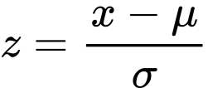

Here,

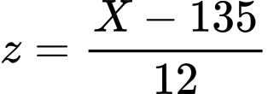

1. a.i)

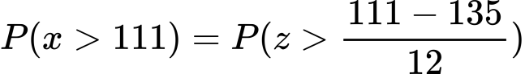

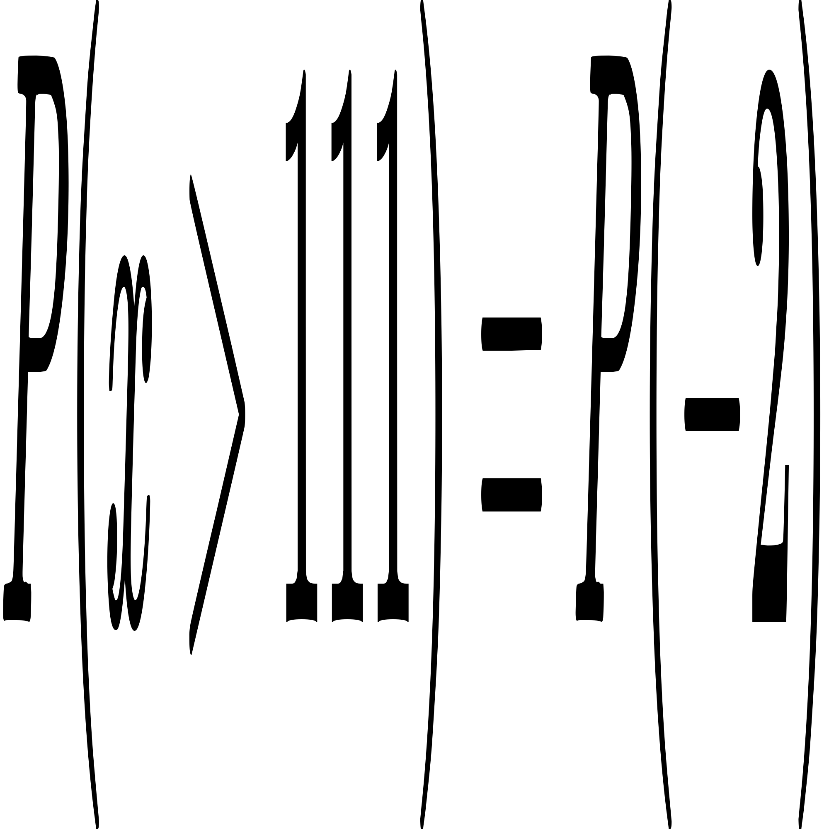

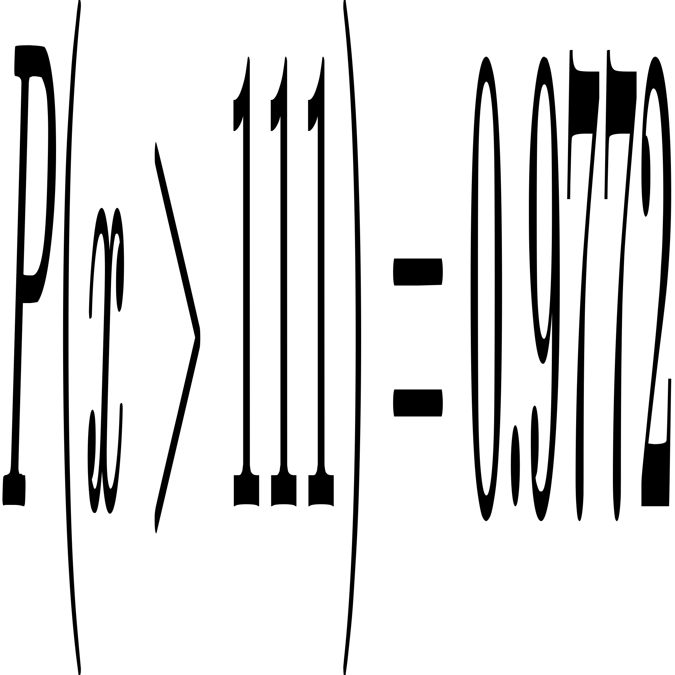

Probability that, without refueling, Anita can travel more than 111 miles = 0.9772

1. a.ii)

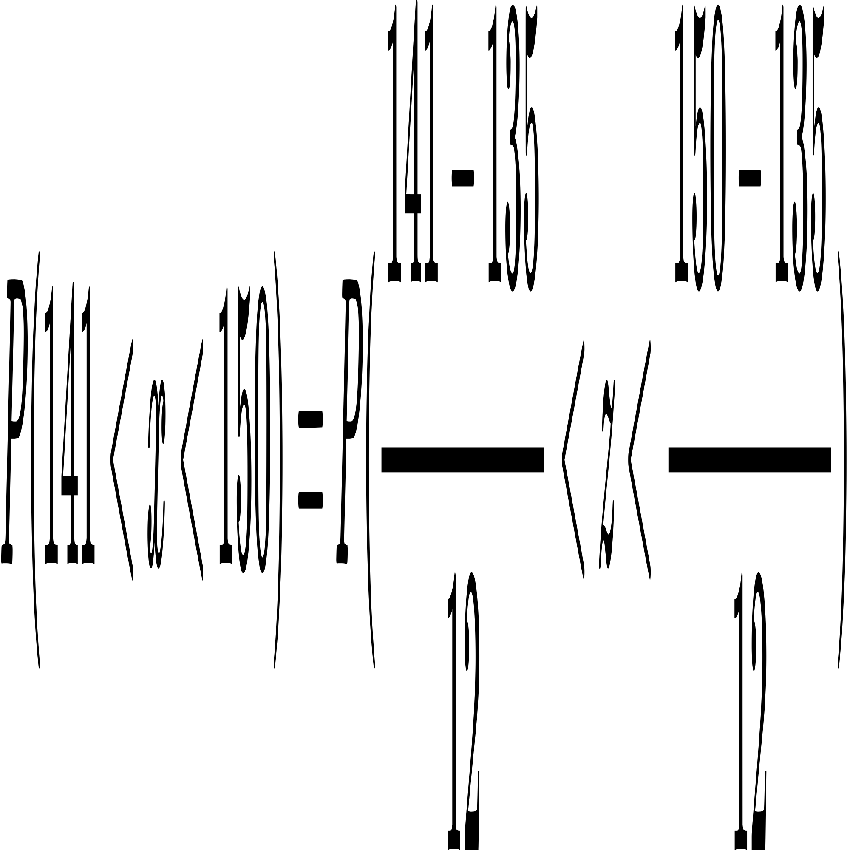

C:/Users/BAB AL SAFA/AppData/Local/Temp/wps.wwcAGHwps

C:/Users/BAB AL SAFA/AppData/Local/Temp/wps.RZyZkAwps

C:/Users/BAB AL SAFA/AppData/Local/Temp/wps.KlUjMewps

C:/Users/BAB AL SAFA/AppData/Local/Temp/wps.FGfdixwps

Probability that, without refueling, Anita can travel between 141 and 150 miles

= 0.2029

5.

n = 45

wps = 63.4

s = 3

H0 : μ > 65

H1 : μ < 65

t - distribution with df = n - 1

= 45 - 1

= 44

**Test Statistic**

We know that, the value of the test statistic t for the sample mean wps is computed as

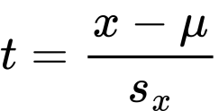 where 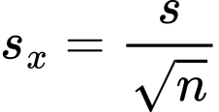

The population standard deviation σ is not known and the sample size is large (n > 30)

Consequently, we will use the t distribution to find the p - value for the test.

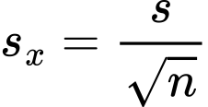

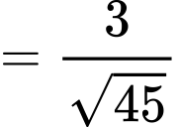

C:/Users/BAB AL SAFA/AppData/Local/Temp/wps.yClaVCwps

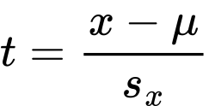

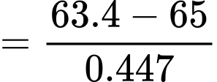

C:/Users/BAB AL SAFA/AppData/Local/Temp/wps.CUhywfwps

df = n - 1

= 45 -1

= 44

p - value < 0.001

The < sign in the alternative hypothesis indicates that the test is left-tailed.

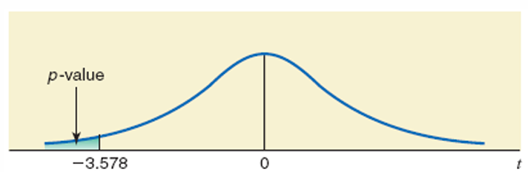

Fig. 1: The required p-value

6.

For Discrete Distribution:

When discrete distribution are used, the problem will have a finite number of scenarios.

The probability of these three scenarios are 1/3 each. Them the problem can be formulated as follows:

**Scenario 1:**

Max

Z1 = 3x1 + 9x2

Subject to

0.5x1 + 1.2x2 < 15000

2.5x1 + x2 < 10000

x1 , x2 < 0

**Scenario 2:**

Max

Z1 = 3x1 + 9x2

Subject to

0.6x1 + 1.3x2 < 17000

2.5x1 + x2 < 10000

x1 , x2 < 0

**Scenario 3:**

Max

Z1 = 3x1 + 9x2

Subject to

0.7x1 + 1.4x2 < 20000

2.5x1 + x2 < 10000

x1 , x2 < 0

7.

The tool crib constitutes a queuing system, with the clerks as its servers and the mechanics as its customers. After gathering some data on inter-arrival times and service times, the OR team has concluded that the queuing system best is the M/M/s model. The estimates of the mean arrival rate λ and the mean service rate (per server) μ are

λ = 120 customers per hour

μ = 80 customers per hour

So, the utilization factor for the two clerks is:

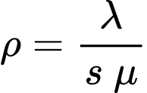

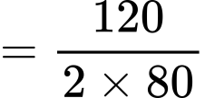

C:/Users/BAB AL SAFA/AppData/Local/Temp/wps.CvWzgJwps

The total cost to the company of each tool crib clerk is about ＄20 per hour,

So, Cs = ＄20

While a mechanic is busy, the value to the company of his or her output averages about ＄48 per hour

So, Cw = ＄48

Therefore, the OR team now needs to find the number of servers (tool crib clerks) s that will

Minimize E(TC) = ＄20 s + ＄48 L

It turns out s = 3 yields the minimum total cost.

8.

If there are r correct answers, there are 10 - r wrong answers and the score is

3r - (10 - r) = 3r - 10 + r

= 4r - 10

The probability of a correct answer = 1/4

The probability of a wrong answer = 1 - (1/4)

= 3/4

Here, by the binomial distribution, the probability of r correct answer is:

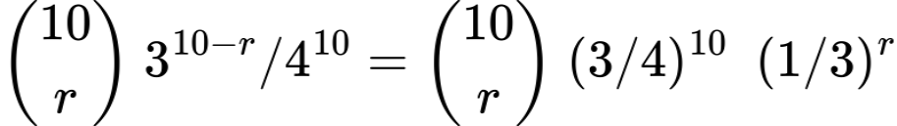

By the Binomial theorem,

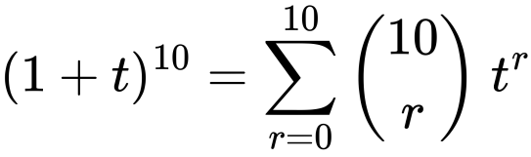

Differentiating both sides with respect to t and then multiplying by t, we have,

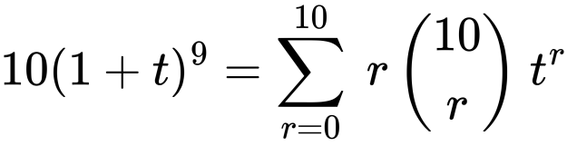

Doing the same operation once more, we have,

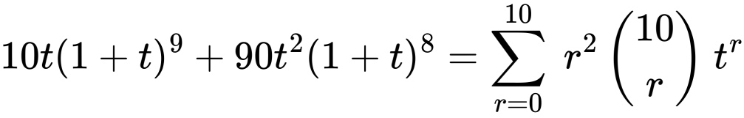

The second formula gives us, on putting t =1/3

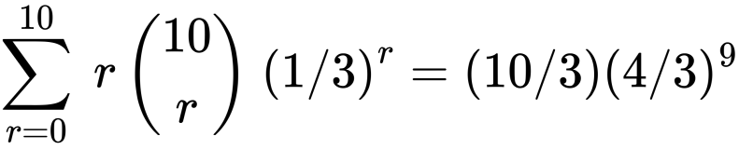

Or Equivalently,

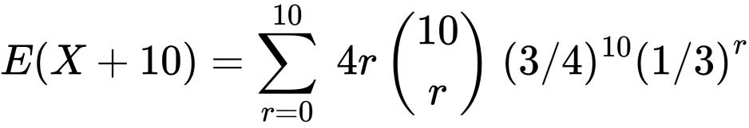

C:/Users/BAB AL SAFA/AppData/Local/Temp/wps.PxXmbpwps

C:/Users/BAB AL SAFA/AppData/Local/Temp/wps.yUCQHjwps

In other words, as we might expect we get,

E(X) = 0

Similarly, we can use the third formula with t = 1/3 to get,

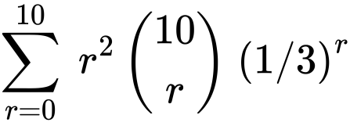

C:/Users/BAB AL SAFA/AppData/Local/Temp/wps.QGLWVLwps

Or Equivalently,

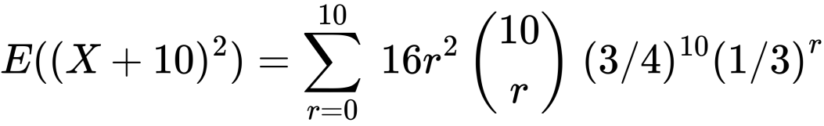

C:/Users/BAB AL SAFA/AppData/Local/Temp/wps.CmJGnIwps

wps

This gives the variance , wps

Hence, the standard deviation, 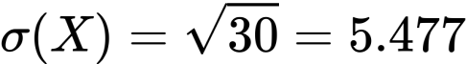

The table of probabilities,

|  |  |  |  |  |  |  |  |  |  |  |  |
| --- | --- | --- | --- | --- | --- | --- | --- | --- | --- | --- | --- |
| r | 0 | 1 | 2 | 3 | 4 | 5 | 6 | 7 | 8 | 9 | 10 |
| 410*P | 59049 | 196830 | 295245 | 26244 | 153090 | 61236 | 17010 | 3240 | 405 | 30 | 1 |

We note that to get at least 50% of the population we can take r < 2

Since the score is then (4r - 10) < -2

It means that more than 50% of the time we will get a negative score.

(8.1) E(X) = 0

(8.2) Most probable score : 0

(8.3) Smallest s such that P(x < s) > (1/2) : ‘negative score’

(8.4) Variance, C:/Users/BAB AL SAFA/AppData/Local/Temp/wps.lRcyiiwps